EART11300 Practical Skills Semester 2 (Chemistry 1)
Finding the dissociation constant of a weak acid



Health and Safety
Hazard | Risk | Control Measures
0.050 M acetic (ethanoic) acid, CH₃COOH   | Causes serious eye irritation, causes skin irritation | Minimum PPE of eye protection, nitrile gloves and a lab coat must always worn throughout the task    Wash hands thoroughly before leaving the lab. In case of skin contact wash immediately with water for several minutes.  Burettes will be filled placed on the floor (below eye level).  In case of eye contact, wash eye immediately with emergency eye-wash kits (remove contact lenses) irrigate for at least 5 minutes.  Phenolphtahalein provided in enclosed dropper bottles, only 2-3 drops required  Clear away spills immediately, notify a demonstrator to assist with this.
0.100 M sodium hydroxide, NaOH  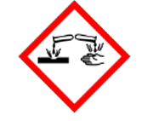 | Corrosive, exposure severe skin burns and eye damage
Phenolphthalein indicator  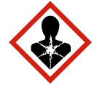 | Dissolved in ethanol which is highly flammable.  Suspected carcinogen, mutagen and may damage fertility.
Standard pH buffers | Not hazardous
Glassware | Breakages lead to risk of cuts | Check apparatus for defects before use. Exercise care especially during clearing away/if glassware is wet. Inform demonstrators of broken items who will follow the correct disposal procedure.

ILOs
By the end of this practical you should be able to:
- Recall the mathematical expressions of pH and the acid dissociation constant and use these to carry out molar calculations for acidic solutions.
- Calibrate a pH probe using suitable buffer solutions.
- Carry out a titration with due attention to safety.
- Calculate the equilibrium constant of a weak monoprotic acid using the half-point of neutralisation on a titration curve plotted from experimental results.

ILO 1 can be assessed in this unit (EART11300). The remaining ILOs are intended to reinforce knowledge of topics in EART11200 CHEMISTRY OF THE EARTH Topic 9 and to develop good laboratory practices in preparation for practical tasks require in the second-year units EART26201 PRINCIPLES OF GEOCHEMISTRY and EART27001 ENVIRONMENTAL CHEMISTRY 1. You may be required to calibrate pH probes in the laboratory or during fieldwork.

Background: recap from EART11200 Chemistry of the Earth Topic 9
An acid is a substance that donates hydrogen ions (H⁺) when dissolved in water (aqueous solution).
The pH of a solution is related to the concentration of hydrogen ions:

pH = -log₁₀[H⁺(aq)] ([X] means “concentration of substance X”)

Strong acids, such as HCl, H₂SO₄ and HNO₃, are almost completely dissociated in solution. The dissociation equations can therefore be shown with a reaction arrow to indicate that the process of dissociation essentially goes to completion:
HCl(aq) H⁺ (aq) + Cl⁻ (aq)
H₂SO₄ (aq) 2H⁺ (aq) + SO₄²⁻ (aq)

Weak acids are only partially dissociated in solution, so the dissociation process is indicated using a reversible reaction arrow. For a general acid which has the formula HA the process is:
HA ⇋ H⁺ (aq) + A⁻ (aq)

Example 1: ethanoic / acetic acid (approximately 0.4 % of acid molecules dissociate)
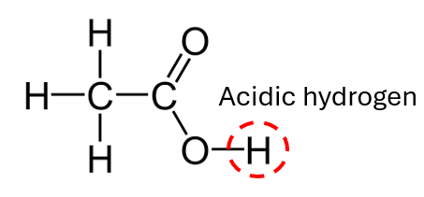
Formula: CH₃COOH (aq) ⇋ H⁺ (aq) + CH₃COO⁻ (aq)
Example 2: carbonic acid (a diprotic acid)
H₂CO₃ (aq) ⇋ H⁺ (aq) + HCO₃⁻ (aq)
HCO₃⁻ (aq) ⇋ H⁺ (aq) + CO₃²⁻ (aq)
Note that pH is affected by both acid strength AND concentration! A dilute solution of a strong acid can still have a relatively high pH. The extent of dissociation (essentially a measure of acid strength) is expressed using an equilibrium constant called the acid dissociation constant, K_{a}:
$$K_{a}= \frac{\left[H^{+}\right][A^{-}]}{[HA]}$$

Aim: To Measure the dissociation constant, K_{a}, of acetic acid
Theory (the chemistry!):
A general weak acid dissociation: HA ⇋ H⁺ (aq) + A⁻ (aq)
Acetic acid dissociation: CH₃COOH (aq) ⇋ H⁺ (aq) + CH₃COO⁻ (aq)
The dissociation constant (K_{a}) for a weak acid may be found from a titration curve which is plotted by measuring the pH values as successive volumes of alkali are added to the acid during an acid-base titration. K_{a} is determined by locating the half equivalence point of neutralisation on the titration curve. At the half equivalence point, half of the moles of acid molecules (HA) will have reacted with the base to form (A⁻) which means [HA] = [A⁻]. K_{a} can be calculated from the pH at half neutralisation as follows:
$$K_{a}= \frac{{[H}^{+}][A^{-}]}{[HA]}$$
At half neutralisation [HA] = [A-] so: $K_{a}=[H^{+}]$
Since pH is defined as: $pH= -log_{10}(\left[H^{+}\right])$
Using the inverse of the pH equation and substituting into the equation for K_{a} at half neutralisation: $K_{a}={10}^{-pH(at half neutralisation)}$

Procedure

Part 1: Calibration of the pH probe
NOTE: A buffer solution maintains an (almost) constant pH when small volumes of acid/alkali are added to it.
- Remove the cap from the pH probe. Wash the probe (around the bulb and over the exterior which will be immersed into your experiment) with deionised water, carefully shake the probe to remove excess water and *gently* pat dry with blue lab tissue

Before proceeding further read all steps 2 – 7 and refer to Fig A-G below
- Turn the probe on and then press the calibration ‘CAL’ button (on the right of the power button) - the screen should read ‘CAL’ (Fig A)
- When the screen displays “7.01 USE” place the pH probe in the yellow pH7 buffer solution (Fig B).
- Leave the probe in the solution while the screen shows ”7.01 rEC” (Fig C).
- When the screen displays “4.01 USE” (Fig D) remove the probe from the pH7 buffer, quickly (but carefully!) rinse the probe with a little deionised water, pat dry and place in the pink pH4 buffer solution (Fig E).
- Leave the probe in the pH4 solution while the display reads “4.01 rEC” (Fig F) and do not remove until the display reads “Stor” (Fig G).
- Once the display shows “Stor” remove the probe from the pH4 buffer. Rinse the pH probe in deionised water and carefully dry with blue tissue. The probe is ready to use.
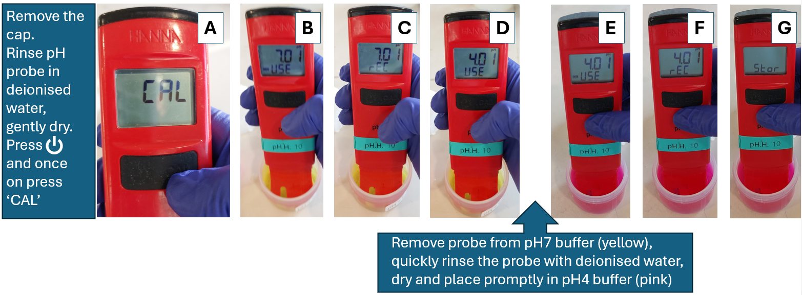

Part 2: Plotting a titration curve
Note: results tables are provided at the back of these worksheets
- Carefully transfer the burette stand and burette to the floor, place a funnel in the top of the burette.
- Place an empty beaker under the burette and with the burette tap open rinse the burette first with deionised water and then with 0.100 M NaOH solution. Discard the rinsings into the sink.
- Close the burette tap, carefully fill the burette past the top reading mark with 0.100 M NaOH and drain again to ensure no air bubbles remain in the tap. Refill/drain burette so the bottom of the meniscus is on 0.00 cm³.
- Remove the funnel and carefully place the burette stand back on the lab bench.
- Use a 25 cm³ pipette (and filler!) to transfer two portions of 25.0 cm³ of 0.050 M acetic acid to a clean 250 cm³ beaker (so that you have 50.0 cm³ acetic acid in total).
- Place the beaker of acetic acid on the magnetic stirring apparatus and beneath the burette. Add the magnetic stirring bar to the beaker. Start the stirring apparatus on the lowest setting for gentle mixing of solutions and to minimise risk of damage to the pH probe.
- Add 2-3 drops phenolphthalein indicator to the acetic acid in the beaker (colour change at end point: colourless pink so the indicator will be initially colourless).
- Place the probe into the solution of acetic acid ensuring that the bulb is fully submerged and avoiding the stirring bar. Record the pH once the measurement is stable in the results table.
- Slowly open the tap to add 2.0 cm³ of NaOH from the burette to the beaker then close the tap, record the pH.
- Continue adding 2.0 cm³ portions of NaOH and record the pH next to the total volume of NaOH added until the NaOH is in excess (identified by stable high pH value probably around pH=12). Note carefully which addition of NaOH coincides with the end point where the pH changes rapidly and the phenolphthalein undergoes the colour change from colourless to pink.
- Repeat the titration but just before the onset of the rapid pH change at the end point (which could be anticipated by checking the results table of the previous titration), add 0.20 cm³ portions of NaOH until the rapid pH change is complete then continue to add 2.0 cm³ portions until the NaOH is in excess (stable high pH achieved).
- Repeat step 11 to ensure concordant results are obtained (ideally, concordant means end points within ±0.10cm³).

Data Analysis
- Calculate your average pH reading for each volume of NaOH added (disregarding any anomalous results).
- Plot a titration curve - this is a graph of the average pH values (y-axis) against the volume of NaOH added (x-axis). The points are joined with a smooth curve.
- Identify the equivalence point of neutralisation (centre of the vertical section of the curve), mark it on your graph and read off the corresponding volume of NaOH added at the equivalence point (x-axis)
- Divide the volume of NaOH added at the equivalence point by 2 to identify the volume of NaOH added at the half-equivalence point of the titration curve. Locate this volume on your graph.
- Use your titration curve to determine the pH at the half-equivalence point
pH at half equivalence point is:
(hint: should be around pH 4.75)

- Hence calculate the the K_{a} for acetic acid (see theory section)?
$$K_{a}={10}^{-pH(at half neutralisation)}$$
K_{a} = 10^{-4.75}
K_{a} = 1.8 x 10⁻⁵ mol dm⁻³
See exemplar graph which was acquired from a very ‘rough’ data set (i.e. only steps 1-10 of the method). The pH at half neutralisation is 4.3 which gives K_{a} = 10 ^{-4.3} = 5 x 10 ⁻⁵ mol dm⁻³
- The accepted value of the K_{a} of acetic acid is 1.8 x 10⁻⁵ mol dm⁻³. What is the %error between your result and the accepted value?

$$\%error=\frac{\left(accepted value-experiment result\right)}{(accepted value)} ×100$$

e.g. 5 x 10 ⁻⁵ mol dm⁻³ from the example above
% error = ((1.8 x 10 ⁻⁵ - 5 x 10 ⁻⁵)/ 1.8 x 10 ⁻⁵) x 100
% error = -178% (!)
Hopefully the %error is smaller than this!

- Can you suggest sources of error in the experiment which might have given rise to the differences between your result and the accepted value (i.e. errors which would account for your result be greater or less than the accepted value)?
See exemplar graph which was acquired from a ‘rough’ data set (i.e. only steps 1-10 of the method). The pH at half neutralisation is 4.3 which gives K_{a} = 10 ^{-4.3} = 5 x 10 ⁻⁵ mol dm⁻³.
K_{a} > 1.8 x 10 ⁻⁵ mol dm⁻³ will arise from pH at half neutralisation being <4.75. Reasons for this: standard solution too dilute (contamination in burette?)/acidic solution too concentrated, pH probe not correctly calibrated etc
K_{a} < 1.8 x 10 ⁻⁵ mol dm⁻³ will arise from pH at half neutralisation being >4.75.
- What modifications could you make to improve the experiment?

Further discussion points
Around the half neutralisation point the pH remains roughly constant (increases very slightly) over a range of added volumes. This is the ‘buffering’ zone where the mixture of the weak acid (HA) and it’s conjugate base anion (A⁻) are present in almost equal amounts and so the system behaves as a buffer. This can be explained by considering the equilibrium reaction for the weak acid dissociation when both the concentration of HA and A⁻ are relatively high:
A general weak acid dissociation: HA ⇋ H⁺ (aq) + A⁻ (aq)
Acetic acid dissociation: CH₃COOH (aq) ⇋ H⁺ (aq) + CH₃COO⁻ (aq)

When a small volume of acid (H⁺) is added to this system at pH close to the half-equivalence point, what happens to the position of equilibrium?
Adding H+ to the system should decrease pH
The system CH₃COOH (aq) ⇋ H⁺ (aq) + CH₃COO⁻ (aq) behaves as a buffer because:
As H⁺ is added the concentration of H⁺ increases and so the position of equilibrium shifts to the left as H⁺ ions reacts with conjugate base anions CH₃COO⁻
H⁺ (aq) + CH₃COO⁻ (aq) CH₃COOH (aq) i.e. the reverse of dissociation
This process removes H⁺ so the decrease in pH is resisted.

When a small volume of base (in this case OH⁻) is added, what happens to the position of equilibrium?
Adding OH- to the system should increase pH
The system CH₃COOH (aq) ⇋ H⁺ (aq) + CH₃COO⁻ (aq) behaves as a buffer because:
The OH⁻ added reacts with H⁺ on the right-hand side of the equation (OH⁻ + H⁺ H₂O). As H⁺ is removed by the reaction with hydroxide, the position of equilibrium shifts to the right and the weak acid molecules CH₃COOH dissociate, releasing H⁺ and resisting the increase in pH.

Results Tables

Rough titration: method steps 1 – 10
Volume NaOH added / cm³ | pH reading
0.0 | 2.3
2.0 | 2.8
4.0 | 3.2
6.0 | 3.6
8.0 | 3.8
10.0 | 4.0
12.0 | 4.2
14.0 | 4.3
16.0 | 4.5
18.0 | 4.7
20.0 | 4.9
22.0 | 5.1
24.0 | 5.4
26.0 | 6.4
28.0 | 11.2
30.0 | 11.5
32.0 | 11.7
34.0 | 11.8
36.0 | 11.9
38.0 | 12.0
40.0

Titrations: steps 11-12
Volume NaOH added / cm³ | pH reading
Volume NaOH added / cm³ | Repeat 1 | Repeat 2 | Repeat 3 | Average

